Subject Name: Wireless Communication

Subject Code: CSP311M

Name: Charvik Patel

Roll no: 1401079

Practical Number: 2

Aim: Write Matlab code of two radio propagation model (okumaras, Hata model) and Plot a Graph of frequency versus Path-loss and distance versus Path-loss

Brief Theory:

1. **Okumaras Model:**
$$L_{50\%}\left(dB\right)=LF-A_{mu}\left(f,d\right)-G\left(h_{re}\right)-G(h_{te})-G_{area}$$

$$L_{50\%}\left(dB\right):50\% pathloss in dB$$

$$LF:free space propagation loss$$

$$A_{mu}\left(f,d\right):Correlation function of frequency and distance$$

$$G\left(h_{re}\right):Gain of Recieving Antenna$$

$$G\left(h_{te}\right):Gain of transmiting Antenna$$

$$G_{area}:Correlation factor due to Diffrent Environment$$

2. **Hata Model:**

Urban Area:

$$L_{u}=69.55+26.16\log_{10}{f-13.82\log_{10}{h_{b}-C_{H}+(44.9-6.55\log_{10}{h_{b})\log_{10}{d}}}}$$

$C_{H}=8.29{(\log_{10}{1.54h_{m}) }}^{2}-1.1dB ;f≤300MHz$

$$C_{H}=3.2{(\log_{10}{11.75h_{m}) }}^{2}-4.97dB ;f≥300MHz$$

$$L_{u}:Pathloss in Urban area$$

$$h_{b}:Hieght of Basestation$$

$$h_{m}:Height of Mobilestation$$

$$C_{H}:Antenna Hieght Correlation factor$$

$$d:Distance between Basestation and Mobilestation(Km)$$

Sub−Urban:

$L_{su}=L_{u}-2(\log_{10}{{\left(\frac{f}{28}\right)) }^{2}-5.4}$

$$C_{H}=3.2{(\log_{10}{11.75h_{m}) }}^{2}-4.97dB ;f≥300MHz$$

$L_{u}:Avrege pathloss in Urban Area in Small City in dB$

$$L_{su}:Pathloss in Sub-Urban Area in dB$$

$$f:frequency$$

Open Area:

$$L_{o}=L_{u}-4.78{(\log_{10}{f) }}^{2}-18.33\log_{10}{f-40.94}dB ;f≥300MHz$$

$$L_{u}:pathloss in Urban Area in Small City in dB$$

$L_{o}:Path loss in open area in dB$

Matlab Code:

1. Okumaras (Distance -> Path-loss):

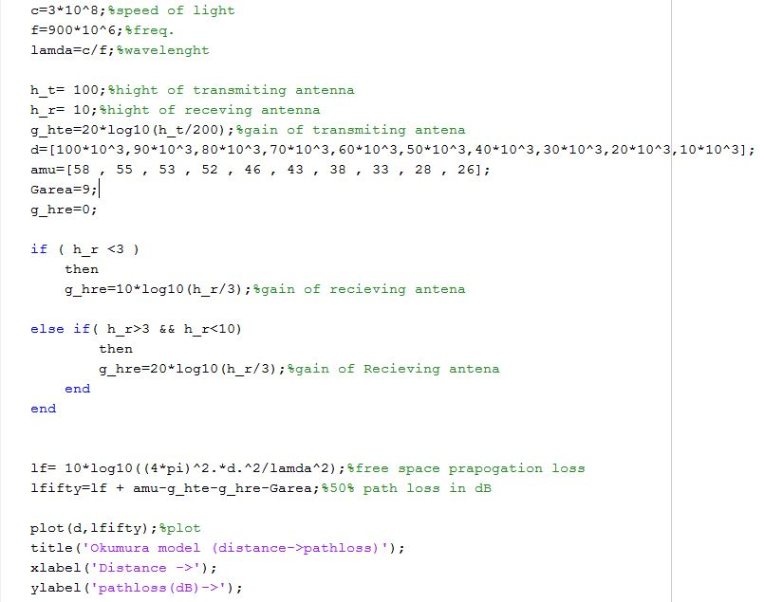

1. Okumaras (Frequency -> Path-loss):

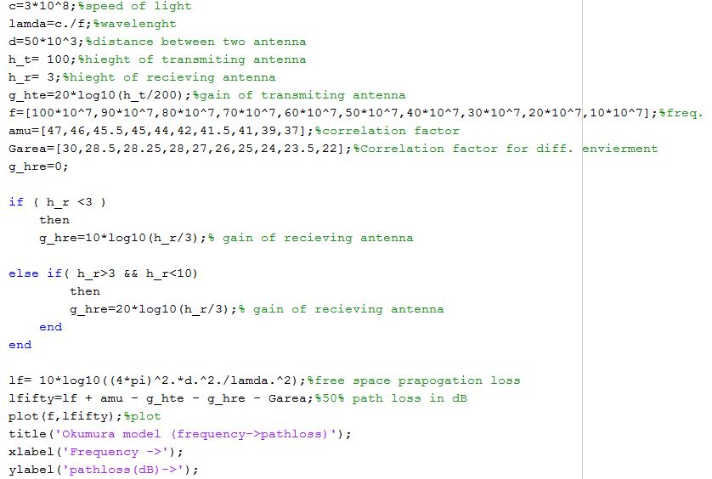

1. Hata (Frequency -> Path-Loss):

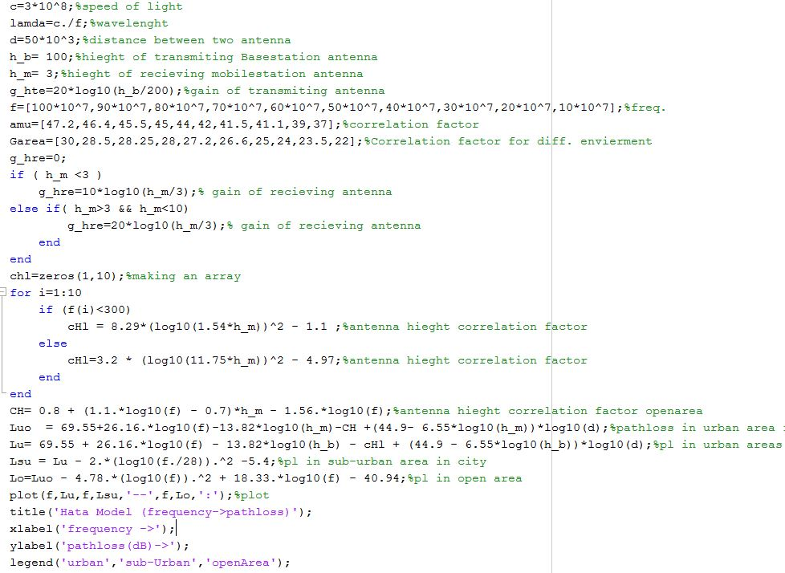

1. Hata (Distance -> Path-Loss):

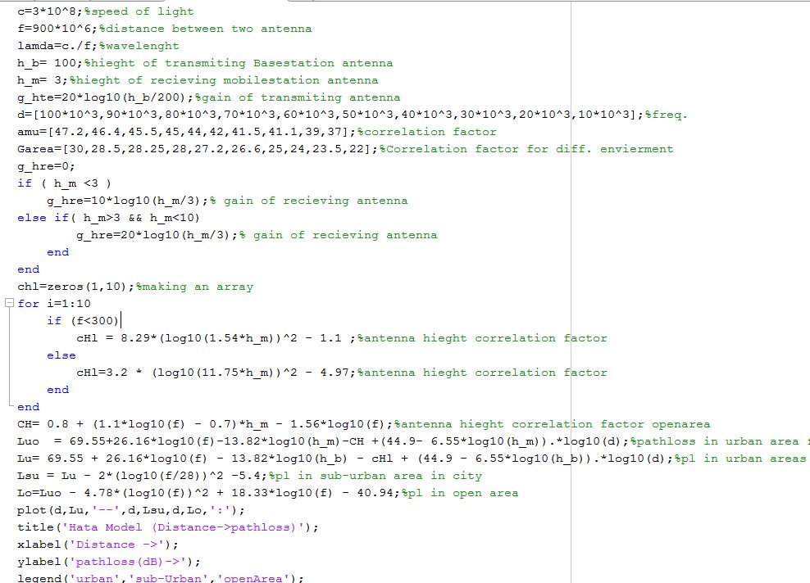

Output:

1. Okumaras (Distance -> Path-loss):

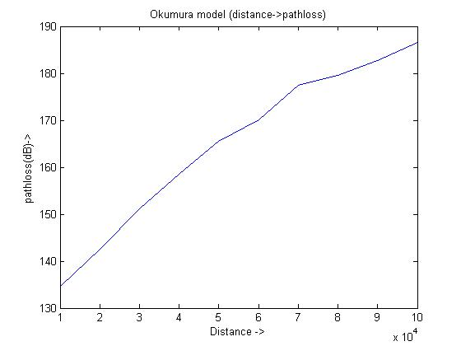

1. Okumaras (Frequency -> Path-loss):

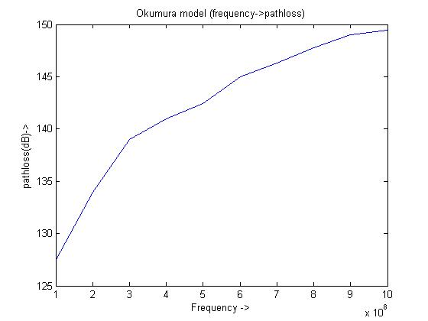

1. Hata (Frequency -> Path-Loss): 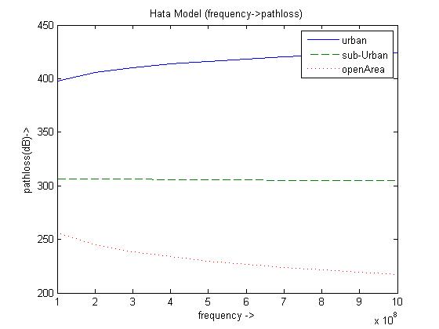

Figure Sub-Urban Graph is Decressing Minor

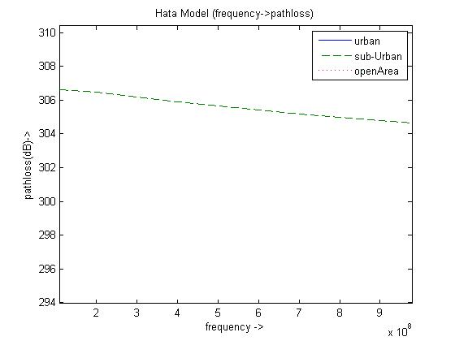

Figure Close-up look of sub-urban

1. Hata (Distance -> Path-Loss):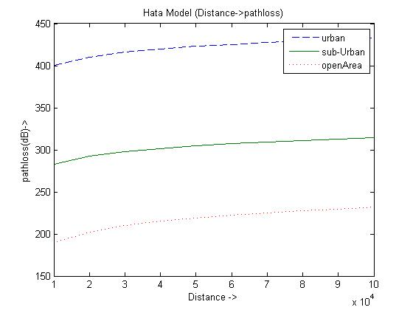

Result Interpretation:

As Distance Increases between Receiving Antenna and Transmitting Antenna Path-loss goes on Increasing Similarly Frequency Increases Path-loss Goes on increasing.